Increment 1 Specification: Admin Access & Catalog
Oct 22, 2026 · @Nir

Overview and scope
Increment 1 delivers an admin who can sign in securely, build the catalog hierarchy and add products whose options are defined per product and whose stock is held per option combination. It is built in weeks 2–3 and demoed at the end of week 3. Increment 2 (storefront) depends on this catalog data.
ID | Requirement | Priority | Source
ADM-01 | Valid credentials on the admin login page open the admin area | Must | US2-AC1
ADM-02 | Invalid credentials are refused with an error message | Must | US2-AC1
ADM-03 | Admin pages cannot be opened without an admin sign-in | Must | US2-AC2
ADM-04 | The server rejects product, stock or order changes not from a signed-in admin | Must | US2-AC2
ADM-05 | Admin can add and edit department, category and subcategory | Must | US2-AC10
ADM-06 | Catalog launches with 1 department, 3 categories, 5 subcategories | Must | US2-AC10
ADM-07 | Admin adds a product with its own option types and stock per combination; it appears to customers | Must | US2-AC3; RQ3, RQ4
ADM-08 | A product cannot be saved without department, category and subcategory | Must | US2-AC11
NFR-02 | Admin passwords are stored as hashes | Must | US2-AC9
In scope: admin sign-in and sign-out, session handling, the server-side guard on every admin page and change request, password hashing, add and edit of the three catalog levels, the seeded launch catalog, product create and edit with photos, option types, option values and a stock grid.
Out of scope (later increments): customer storefront pages (Inc 2), the unavailable flag and price/stock sync checks (ADM-09–10, Inc 2), orders and stock decrement (Inc 3), graphics per catalog level (ADM-11, Inc 4). ADM-07's "appears in the customer product list" is verified through a basic read-only product list endpoint until the storefront ships in Inc 2.

Actors, assumptions and dependencies
The store admin is the only actor in this increment; the system acts on the admin's behalf only after a successful sign-in.
Actor | Goal in Inc 1
Store admin | Sign in, set up the catalog hierarchy, add and edit products, options and stock
System | Authenticate the admin, enforce access on the server, validate and store catalog data
Shopper (indirect) | Sees products the admin adds once the storefront ships in Inc 2
Assumptions
- There is one admin role. All admins have the same permissions.
- Admin accounts are created by the delivery team at deployment, not through a self-service screen (see open question Q2).
- The server is the authority for permissions and data; browser checks are for convenience only (NFR-03).
- Prices are stored in one currency with two decimals (currency to confirm, Q4).
- Stock is a whole number per option combination (RQ3), and option types are defined per product (RQ4).
Dependencies
- Architecture, data model and dev environment from week 1 (Inc 0).
- Seed catalog content confirmed by the product owner before the week 2 build.
- Photo storage location agreed before product photos are built (week 3).

Admin sign-in (ADM-01–04, NFR-02)
Only a signed-in admin can open an admin page or change catalog data, and the server enforces this on every request.
Business rules
Rule | Description | Req
SI-1 | The admin login page asks for a username (or email) and a password. Both are required. | ADM-01
SI-2 | Valid credentials create a server-side session and open the admin home page. | ADM-01
SI-3 | Invalid credentials show one generic message that does not reveal which field was wrong. No session is created. | ADM-02
SI-4 | Any admin page requested without a valid session redirects to the login page. After sign-in the admin returns to the page first requested. | ADM-03
SI-5 | Every request that creates, changes or deletes catalog, stock or order data is checked for a valid admin session on the server. Without one it is rejected (401/403) and nothing changes. | ADM-04, NFR-03
SI-6 | Sign-out ends the session on the server. Back button or a saved URL afterwards leads to the login page. | ADM-03
SI-7 | Sessions expire after a period of inactivity. Proposed default: 30 minutes (confirm, Q1). | ADM-03
SI-8 | Repeated failed attempts are slowed down. Proposed default: 5 failures in 15 minutes locks the account for 15 minutes (confirm, Q1). | ADM-02
SI-9 | Passwords are stored only as salted hashes from an adaptive algorithm (bcrypt or Argon2). Plain passwords are never stored or logged. | NFR-02
SI-10 | The login page and the admin area are served over HTTPS only. | ADM-04
Acceptance criteria
- Given I am on the admin login page, when I enter a valid username and password, then I reach the admin home page.
- Given I am on the admin login page, when I enter a wrong password or an unknown username, then I see "Username or password is incorrect" and stay on the login page.
- Given I am not signed in, when I open any admin URL, then I am sent to the login page.
- Given I am not signed in, when a request to create or change catalog, stock or order data reaches the server, then it is rejected and no data changes.
- Given I have signed out, when I press Back or open a saved admin URL, then I am sent to the login page.
- Given an admin account exists, when the database is inspected, then its password appears only as a salted hash, and two admins with the same password have different hashes.

Catalog hierarchy (ADM-05, ADM-06)
The catalog is a strict three-level tree: department, then category, then subcategory (room). Every product hangs from one subcategory.
Level | Launch values | Parent | Rules
Department | Home Décor | none | Name required, 1–60 characters, unique across departments
Category | Cushions, Bed sheets, Curtains | Department | Name required, 1–60 characters, unique within its department
Subcategory (room) | Kitchen, Bedroom, Bathroom, Living room, Patio | Category | Name required, 1–60 characters, unique within its category
Business rules
Rule | Description | Req
CH-1 | The admin can add an item at each level. A new category needs a department; a new subcategory needs a category. | ADM-05
CH-2 | The admin can rename an item at each level. Products keep their placement; storefront labels show the new name. | ADM-05
CH-3 | The admin can move a category to another department, or a subcategory to another category. Its products move with it. | ADM-05
CH-4 | The seed script creates Home Décor, its 3 categories and the 5 rooms under each category (15 subcategory records). It runs once and is safe to re-run. | ADM-06
CH-5 | Deleting a level is not part of Inc 1. A later rule must block deleting a level that still holds products (Q6). | ADM-05
CH-6 | Graphics per level (CSS, banners, icon) are not built now; the data model leaves room for them (ADM-11, Inc 4). | ADM-11
The rooms are repeated under each category so that a filter such as "Bedroom cushions" or "Kitchen curtains" (CUS-06) is a simple subcategory match. Whether rooms should instead be one shared list is open question Q3.
Acceptance criteria
- Given a fresh installation, when I open the catalog screen, then I see Home Décor with Cushions, Bed sheets and Curtains, each holding Kitchen, Bedroom, Bathroom, Living room and Patio.
- Given I am signed in, when I add a department, a category or a subcategory with a valid name, then it appears at the right place in the tree.
- Given I am signed in, when I rename an item, then the new name shows in the tree and its products keep their placement.
- Given a category already has a subcategory named Kitchen, when I add another Kitchen to it, then the save is refused with "This name is already used here".

Product model: options and stock (ADM-07, ADM-08)
Each product defines its own option types (such as Size, Color or Dimensions), and stock is held for every combination of one value per option type, not for the product as a whole (RQ3, RQ4).
Product fields
Field | Required | Rules
Name | Yes | 1–120 characters; used by customer search (CUS-02)
Department, category, subcategory | Yes, all three | Chosen from the hierarchy; subcategory must belong to the category, category to the department
Description | Yes | Up to 2,000 characters
Material | Yes | Up to 120 characters, e.g. "100% linen"
Photos | Yes, at least 1 | JPG or PNG; first photo is the main one; admin can reorder (limits in Q5)
Price | Yes | Greater than 0, two decimals, one currency (Q4)
Option types | No (see OP-6) | Each has a name and at least one value
Stock per combination | Yes, per combination | Whole number, 0 or more; blank is saved as 0
Option and stock rules
Rule | Description | Req
OP-1 | The admin adds option types to a product by name. Names are unique within the product. | ADM-07, RQ4
OP-2 | Each option type has one or more values, unique within that type, in an order the admin sets. | ADM-07, RQ4
OP-3 | The system builds every combination of one value per option type and shows them as a stock grid. | ADM-07, RQ3
OP-4 | The admin enters a stock quantity for each combination. Stock lives only on combinations, never on the product. | ADM-07, RQ3
OP-5 | Adding a value adds its combinations with stock 0. Removing a value removes its combinations after the admin confirms; the confirmation shows the stock that will be dropped. | ADM-07
OP-6 | A product with no option types has a single default combination that holds its stock (Q8). | ADM-07
OP-7 | A saved product becomes visible to the customer product list in the same request. | ADM-07
OP-8 | A product cannot be saved until a department, a category and a subcategory are all chosen. The server checks this as well as the form. | ADM-08, NFR-03
Worked example
"Linen square cushion" in Cushions › Living room has two option types: Size (45 × 45 cm, 50 × 50 cm) and Color (Sand, Sage, Charcoal). The system builds 2 × 3 = 6 combinations:
Size | Color | Stock
45 × 45 cm | Sand | 12
45 × 45 cm | Sage | 8
45 × 45 cm | Charcoal | 0
50 × 50 cm | Sand | 5
50 × 50 cm | Sage | 3
50 × 50 cm | Charcoal | 7
A curtain could instead define Width, Drop and Color; each product carries only the options that make sense for it. The values above are an example, not real catalog data.
Acceptance criteria
- Given I am signed in, when I save a product with name, placement, description, material, at least one photo, price, its option types and a stock figure for each combination, then it is saved and appears in the customer product list.
- Given I add Size with 2 values and Color with 3 values, when I open the stock grid, then I see exactly 6 combinations, each with its own stock field.
- Given a product has no option types, when I save it, then it has one stock field.
- Given I leave the department, category or subcategory empty, when I save, then the save is refused and a message appears next to each missing field.
- Given a save request reaches the server without a subcategory, when the server processes it, then it is rejected even if the form check was bypassed.
- Given I enter -1 or 2.5 as stock, when I save, then the save is refused with "Stock must be a whole number, 0 or more".

Data model
Seven catalog entities carry Inc 1, and stock sits only on the option combination, which is what orders will reduce in Inc 3.
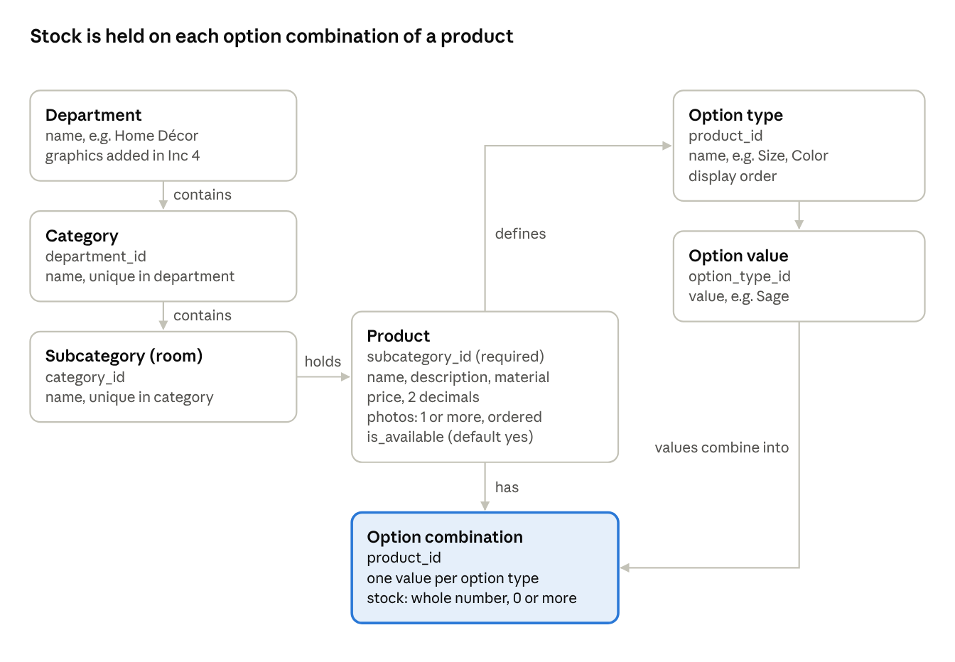
Inc 1 data model · 7 entities, arrows run from one to many
Each arrow runs from one record to many. A product's department and category come from its subcategory, so placement cannot contradict itself. Admin users are a separate table (username, password hash, failed-attempt count, lock time) with no link to catalog records in Inc 1.

Admin screens and flows
Inc 1 needs five admin screens. All except the login page sit behind the session check (SI-4).
Screen | Purpose | Main actions
Login | Sign in | Enter username and password; submit
Admin home | Starting point after sign-in | Go to Catalog or Products; sign out
Catalog | View and edit the hierarchy as a tree | Add, rename or move a department, category or subcategory
Product list | Find products to edit | Filter by category and subcategory; search by name; add product
Product editor | Create and edit one product | Edit details and placement, upload and order photos, define options, fill the stock grid, save
Add a product (main flow)
- Admin opens Product list and selects Add product.
- Admin enters name, description, material and price.
- Admin chooses department, then category, then subcategory; each list shows only the children of the level above.
- Admin uploads one or more photos and sets the main one.
- Admin adds option types and their values, or leaves the product with none.
- System shows the stock grid with one row per combination; admin enters each quantity.
- Admin selects Save. The system validates on the server, saves the product and its combinations in one transaction, and shows "Product saved".
Alternative paths
- Step 7 fails validation: nothing is saved, the editor stays open with the admin's input kept, and each problem is shown beside its field.
- Session expires during editing: the save is rejected, the admin signs in again and is returned to the editor; unsaved input is lost unless the browser kept it (Q1).

Validation rules and messages
Every rule below runs on the server; the same rules run in the form only to give faster feedback (NFR-03). Messages appear beside the field they concern.
Where | Condition | Message
Login | Username or password empty | "Enter your username" / "Enter your password"
Login | Credentials do not match | "Username or password is incorrect"
Login | Account temporarily locked (SI-8) | "Too many attempts. Try again in 15 minutes."
Any admin save | Session missing or expired | "Your session has ended. Sign in again."
Catalog | Name empty or over 60 characters | "Enter a name of 1 to 60 characters"
Catalog | Name already used under the same parent | "This name is already used here"
Product | Name, description, material or price empty | "This field is required"
Product | Department, category or subcategory not chosen | "Choose a department" / "Choose a category" / "Choose a subcategory"
Product | Subcategory not under the chosen category | "This subcategory is not in the chosen category"
Product | No photo | "Add at least one photo"
Product | Photo not JPG or PNG, or over the size limit | "Use a JPG or PNG under the size limit" (limit in Q5)
Product | Price 0, negative or more than 2 decimals | "Enter a price greater than 0 with up to 2 decimals"
Options | Option type with no values | "Add at least one value for this option"
Options | Duplicate option type or value name | "This name is already used for this product"
Stock | Negative or not a whole number | "Stock must be a whole number, 0 or more"

Traceability and definition of done
Each Inc 1 requirement maps to the rules in this spec and to the test cases in the traceability matrix; QA executes them in week 3.
Req | Spec rules | Test cases
ADM-01 | SI-1, SI-2 | TC-ADM-01-01
ADM-02 | SI-3, SI-8 | TC-ADM-02-01, TC-ADM-02-02
ADM-03 | SI-4, SI-6, SI-7 | TC-ADM-03-01, TC-ADM-03-02
ADM-04 | SI-5, SI-10 | TC-ADM-04-01, TC-ADM-04-02
ADM-05 | CH-1, CH-2, CH-3, CH-5 | TC-ADM-05-01, TC-ADM-05-02
ADM-06 | CH-4 | TC-ADM-06-01
ADM-07 | OP-1 to OP-7 | TC-ADM-07-01, TC-ADM-07-02
ADM-08 | OP-8 | TC-ADM-08-01
NFR-02 | SI-9 | TC-NFR-02-01, TC-NFR-02-02
Definition of done for Inc 1
- ☐ All nine requirements built and code reviewed
- ☐ All Inc 1 test cases pass; no open critical or high defects
- ☐ Server rejects unauthenticated change requests, verified with direct requests (not only through the UI)
- ☐ Seed catalog present on the test server
- ☐ At least one product per category entered with options and stock, ready for Inc 2
- ☐ Product owner accepts the demo at the end of week 3
- ☐ Traceability matrix updated

Open questions
The source stories don't settle these points. Each one has a proposed default so the build in week 2 can start; answers are needed by the end of week 2.
# | Question | Proposed default | Affects
Q1 | What session timeout and failed-login lockout should apply? | 30 minutes idle; 5 failures in 15 minutes lock the account for 15 minutes | SI-7, SI-8
Q2 | How are admin accounts created, and how many admins will there be? | Created by the delivery team at deployment; no account screens in Release 1 | Assumptions
Q3 | Are rooms one shared list, or separate subcategories under each category? | Separate under each category (15 records) | CH-4, CUS-06
Q4 | Which currency are prices in? | One currency, two decimals | Product price
Q5 | What are the photo limits (format, file size, number per product)? | JPG or PNG, 5 MB each, up to 10 per product | Product photos
Q6 | Can the admin delete catalog levels and products, and what happens to their products and order history? | No deletion in Inc 1; decide before Inc 3 | CH-5
Q7 | Is there a limit on option types or values per product? | No hard limit; the stock grid is tested up to 3 option types and 60 combinations | OP-1 to OP-3
Q8 | Can a product have no options at all? | Yes, with one default stock field | OP-6

